**Print Self-Dividing Numbers**

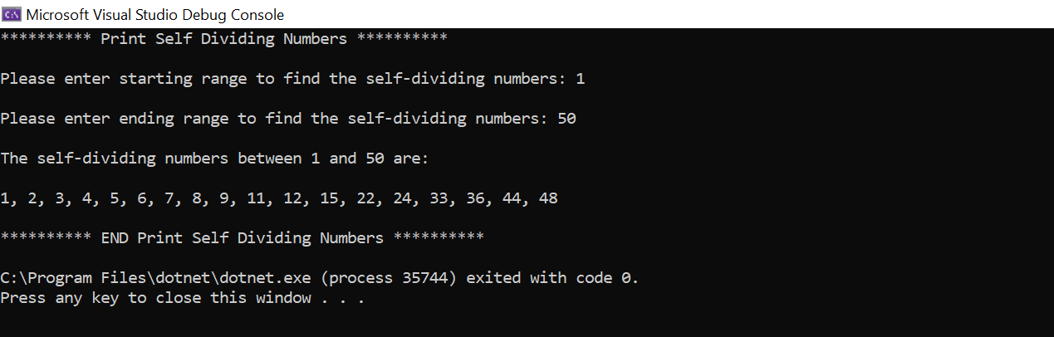

**Print Series till n terms**

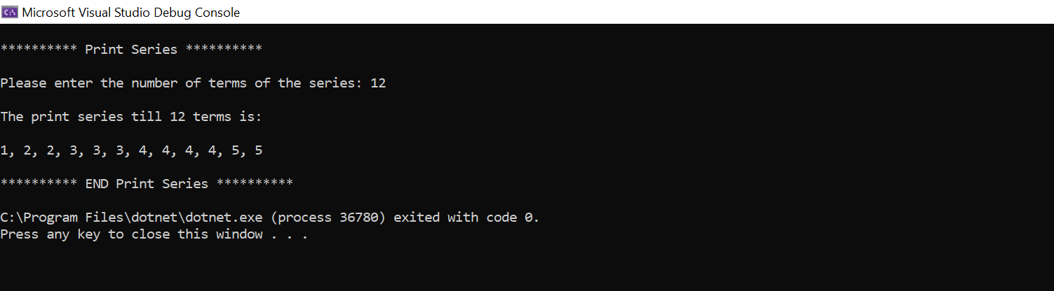

**Print Inverted Triangle Pattern**

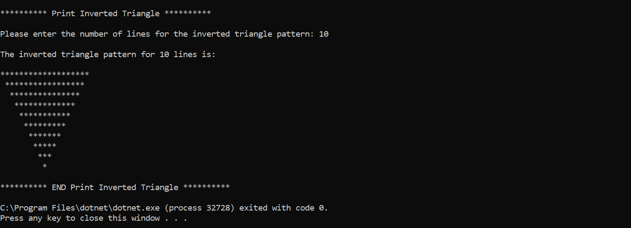

**How many of the stones you have are also jewels**

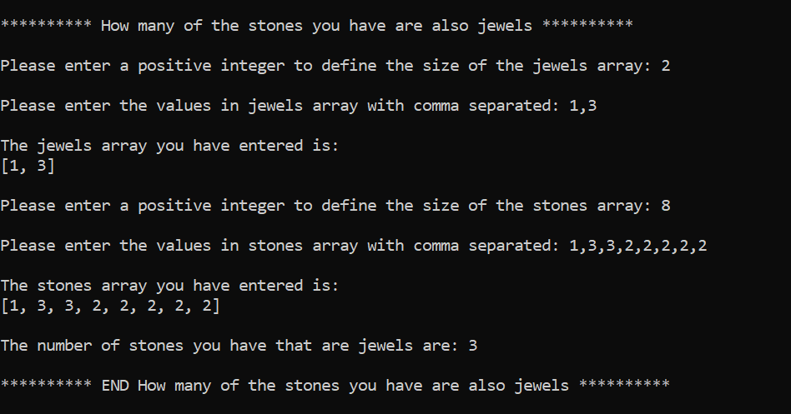

**largest common contiguous subarray**

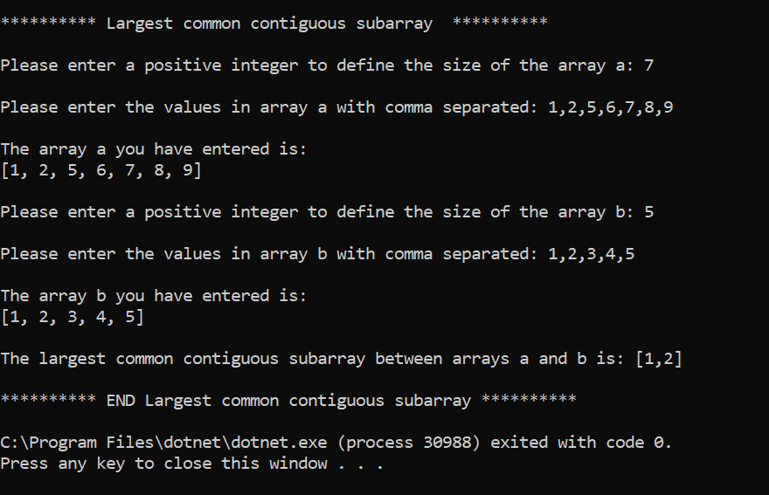

**Consolidated Output**

